SISTER NIVEDITA MONTESSORY SCHOOL
ENGLISH
CLASS –III
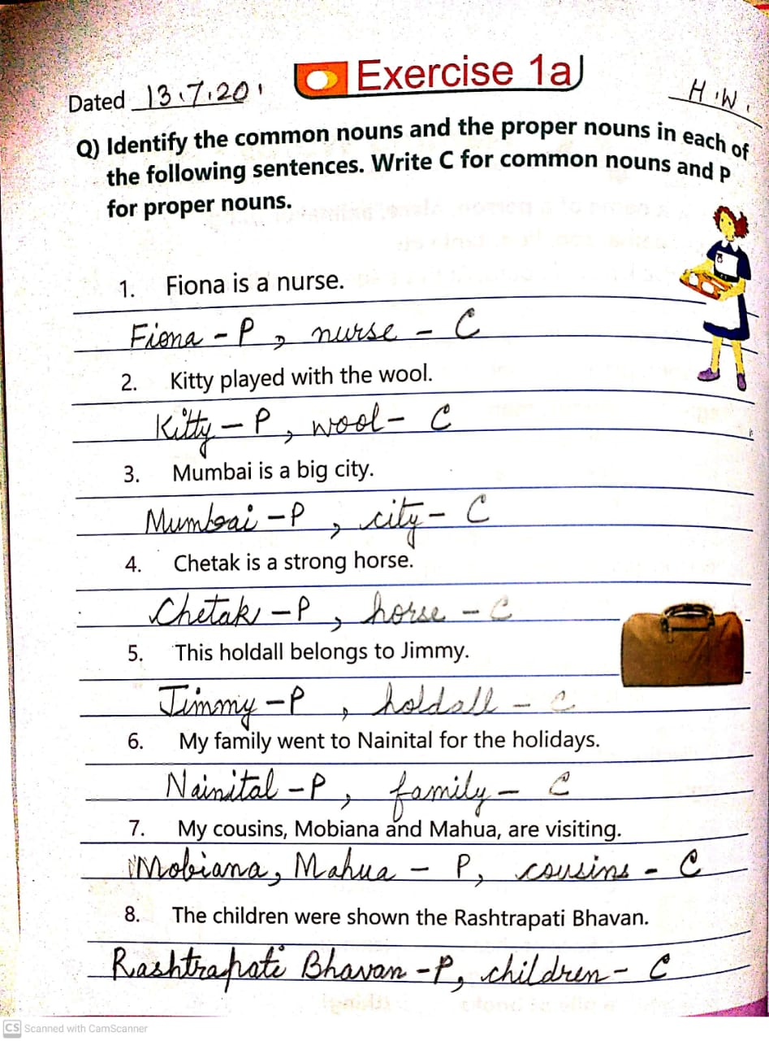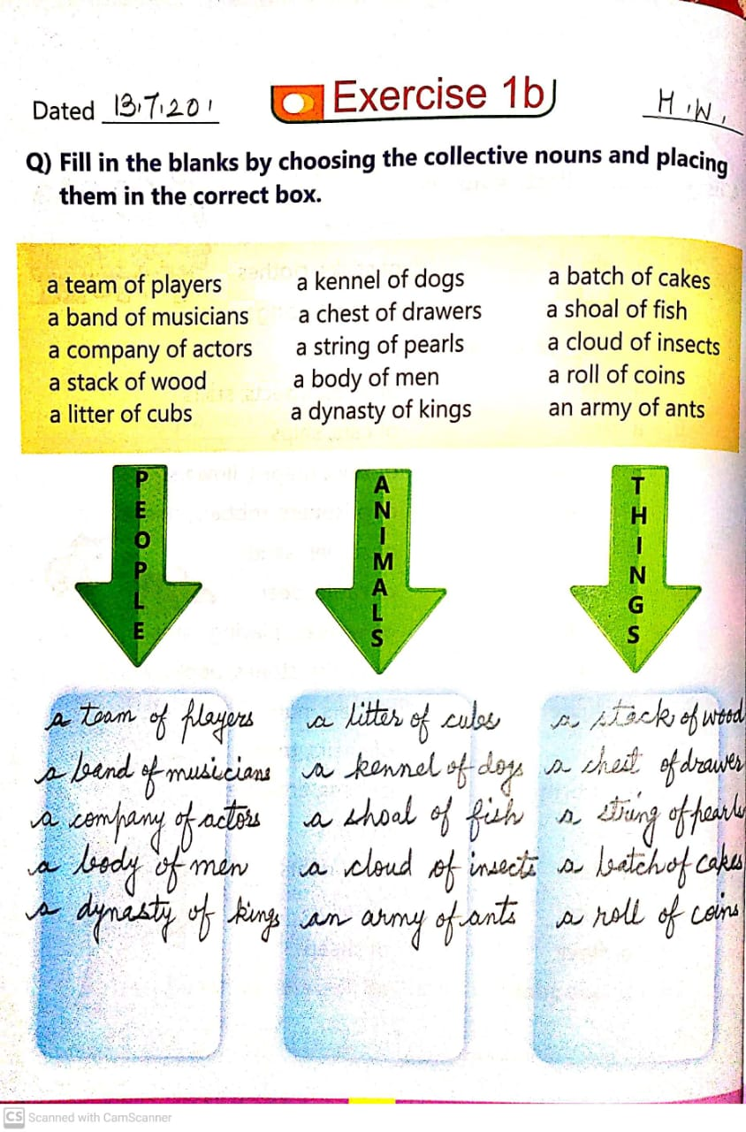

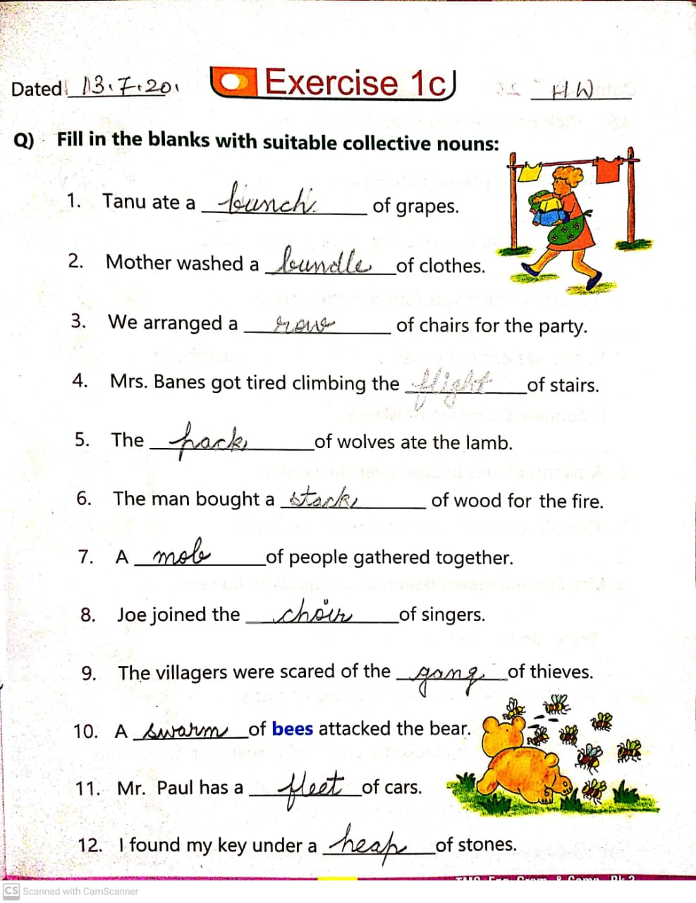
COMPLETE PG.NO-12.

